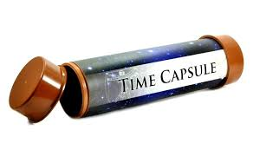

**Time Capsule Activity**

**Directions**: A time capsule is a container storing a selection of objects chosen as being typical of the present time, buried for discovery in the future. You will be choosing 6 objects from the present that you think are important enough to be included in a time capsule so people 100 or even 1000 years from now would understand how we lived. You will need to explain each of your objects and share your opinion about what they mean to the present day and what they might say to the future. For each object, you need a picture. Further, your responses for each object will be at least 5-7 sentences long. You will be putting it on a google document and uploading your final time capsule to Turnitin.com. The rubric is as follows:

RUBRIC:

6 objects from the present time (images) _________/12

Paragraph for each image (5-7 sentences) _________/30

(what does object mean today and what it could say in future)

Varied sentence structure/good word choice/spelling/grammar _________/10

Organized and creative _________/8

TOTAL: _________/60

**\* I HAVE INCLUDED THE START OF AN EXAMPLE ON THE NEXT PAGE – YOU CAN ONLY USE ONE OF MY EXAMPLES; HOWEVER, YOU NEED TO HAVE YOUR OWN WRITING.**

**YOU WILL TURN IN TO TURNITIN.COM BY END OF DAY TODAY.**

**My Time Capsule – 2023-2024**

Object 1: **Apple I Phone**

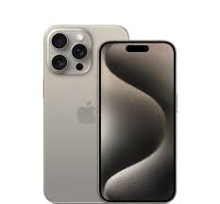

The I Phone is something most individuals today have. It is something people could not live without. These phones have everything needed including gaming apps, tracking devices, Internet access, maps, voicing systems, calling, facetiming, and much more. In the future, these phones are only going to get more advanced and may even include faster technology than it has today. This device continues to advance, so I am sure that future phones will have much more.

Object 2: **Stanley Cup**

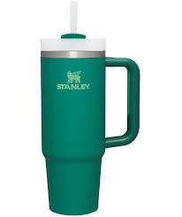

The Stanley cup became a trend in the past couple of years. New colors and sizes surface each day. This drink cup can hold a ton of any type of beverage; however, it was used mainly for water. If ice was added, the water in the Stanley would stay cold all day long. In the future, I am sure that people will continue to use these cups as they are durable and last a long time.